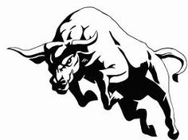

PARAS SHARMA

2015CSA1126

Stock Exchange

HISTORY | CONCEPT | CURRENT SCENARIO

# Stock Exchange

HISTORY | CONCEPT | CURRENT SCENARIO

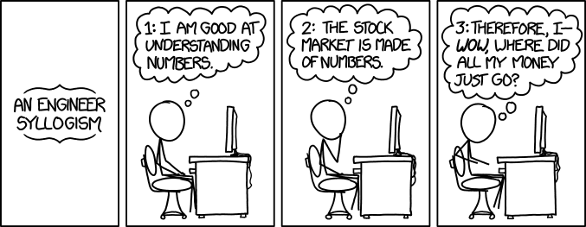

A long time ago, humans ran businesses with just their money. The businesses they ran were small and they grew the businesses only with their own profits. However, not all businesses can be built with your own money.  What if you wanted to build a new factory that costs more than a million dollars? Banks won't lend money for young companies and your friends won't have that much.

**History**

The first genuine stock markets didn’t arrive until the 1500s. However, there were plenty of early examples of markets which were *similar*to stock markets.

In the 1100s, for example, France had a system where **courtiers de change** managed agricultural debts throughout the country on behalf of banks.

Later, the merchants of Venice were credited with trading government securities as early as the 13th century. Soon after, bankers in the nearby Italian cities of Pisa, Verona, Genoa, and Florence also began trading government securities.

The East India Company is widely recognized as the world’s first publicly traded company. There was one simple reason why the East India Company became the first publicly traded company.

Put simply, sailing to the far corners of the planet was too risky for any single company. When the East Indies were first discovered to be a haven of riches and trade opportunities, explorers sailed there in droves. Unfortunately, few of these voyages ever made it home. Ships were lost, fortunes were squandered, and financiers realized they had to do something to mitigate all that risk.

Thus, a unique corporation was formed in 1600 called “Governor and Company of Merchants of London trading with the East Indies”. This was the famous East India Company and it was the first company to use a limited liability formula.

Investors realized that putting all their “eggs into one basket” was not a smart way to approach investment in East Indies trading. Let’s say that a ship returning from the East Indies had a 33% chance of being seized by pirates. Instead of investing in one voyage and risking the loss of all invested money, investors could purchase shares in multiple companies. Even if one ship was lost out of 3 or 4 invested companies, the investor would still make a profit.

The formula proved to be very successful. Within a decade, similar charters had been granted to other businesses throughout England, France, Belgium, and the Netherlands.

In 1602, the Dutch East India Company officially became the world’s first publicly traded company when it released shares of the company on the Amsterdam Stock Exchange. Stocks and bonds were issued to investors and each investor was entitled to a fixed percentage of East India Company’s profits.

There was no regulation and few ways to distinguish legitimate companies from illegitimate companies. Thus, the bubble quickly burst. Companies stopped paying dividends to investors and the government of England banned the issuing of shares until 1825.

Despite the ban on issuing shares, the **London Stock Exchange** was officially formed in 1801. Since companies were not allowed to issue shares until 1825, this was an extremely limited exchange. This prevented the London Stock Exchange from preventing a true global superpower.

That’s why the creation of the **New York Stock Exchange** (NYSE) in 1817 was such an important moment in history.

***“The London Stock Exchange was the main stock market for Europe, while the New York Stock Exchange was the main exchange for America and the world.”***

**Concept**

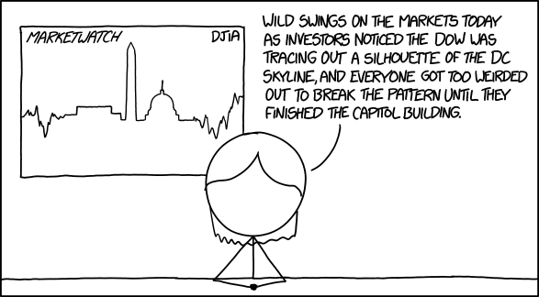

**What is a Stock?**

When you buy a stock, you're buying a piece of the company. When a company needs to raise money, it issues shares. This is done through an initial public offering (IPO), in which the price of shares is set based how much the company is estimated to be worth, and how many shares are being issued. The company gets to keep the money raised to grow its business, while the shares (also called stocks) continue to trade on an exchange, such as the New York Stock Exchange (NYSE).

Traders and investors continue to buy and sell the stock of the company on the exchange, although the company itself no longer receives any money from this type of trading. The company only receives money from the IPO.

Stocks in a company provide you a share of the company's future profits in return for the capital invested. For instance, if you buy 1 stock of Apple now, you will be assured one-billionth of Apple's profits in the future (as there are almost a billion such stocks that Apple has issued now).   
  
**Listing:**In a stock market, 1000s of companies are listed and these companies (called public companies - as they have given out their shares to common public) pay a fee to the exchanges, along with a promise to provide all important info to the markets. In return they get an opportunity to put their company in the stock market's board & can get money from people visiting the market. The first time a company's stock appears on the stock market's board is called an **IPO (Initial Public Offer)**.   
  
**Brokers:**Conceptually, a stock exchange is like eBay. These guys allow companies to be listed and connect the buyers & sellers. Since millions of people trade in the market and it is practically impossible for these exchanges to deal with all the individuals, they have assigned brokers who act between the exchanges and the individuals.   
  
**Stock Value:** We will use a term **EPS (Earnings per share)**that is exactly as it sounds. It is the profits of the company divided by number of shares. For instance, Apple has $41 billion in profits and about 950 million shares, giving an EPS of about 41000/950 = $44/share. Thus, if you own a share of Apple, you are entitled to 44 bucks of Apple's profits this year. 

**Buying Shares**: Traders and investors continue to trade a company's stock after the IPO because the perceived value of company changes over time.Investors can make or lose money depending on whether their perceptions agree with "the market." The market is the vast array of investors and traders who buy and sell the stock, pushing the price up or down.

While there are different [classes of shares](http://www.investopedia.com/terms/c/class.asp) (a company can issue shares more than once), typically owning shares gives you [voting rights](http://www.investopedia.com/terms/v/votingright.asp) equal to the number of shares you own. Shareholders as a whole, based on their individual votes, select a [board of directors](http://www.investopedia.com/terms/b/boardofdirectors.asp) and can vote on major decisions the company is making.  
  
**Selling Shares:** For every [stock transaction](http://www.investopedia.com/articles/basics/03/032103.asp), there must be a buyer and a [seller](http://www.investopedia.com/terms/s/seller.asp). When you buy 100 shares of stock (called a "[lot](http://www.investopedia.com/terms/r/roundlot.asp)") someone else must sell it to you. Either buyers or sellers can be more aggressive than the other, pushing the price up or down.

When the price of a stock goes down, sellers are more aggressive because they are willing to sell at a lower and lower price. The buyers are also timid and only willing to buy at lower at lower prices. The price will continue to fall until the price reaches a point where buyers step in and become more aggressive and willing to buy at higher prices, pushing the price back up.

Investors don't all have the same agenda, which leads traders to sell stocks at different times. One investor may hold stock that has grown significantly in price and sells to lock in that profit and extract the cash. Another [trader](http://www.investopedia.com/terms/t/trader.asp) may have bought at a higher price than the stock now sells for, putting the trader in a losing position. That trader may sell to keep the loss from getting bigger. Investors and traders may also sell because they believe a stock is going to go down, based on their research, and want to take their money out before it does.

**Volume:** How many shares change hands in a day is called [volume](http://www.investopedia.com/terms/v/volume.asp). Many stocks on major exchanges, such as the [NYSE or NASDAQ](http://www.investopedia.com/articles/basics/03/103103.asp), have millions of shares issued. That means potentially thousands of investors in a stock may decide to buy or sell on any day. A stock that has lots of daily volume is attractive to investors because the volume means they can easily buy or sell their shares whenever they please.

***Shares can be bought or sold at any time, assuming there is enough volume available to complete the transaction, which means investors can cut losses or take profits whenever they wish.***

**Market Estimation:**  
In short, we try to use every possible information to guess the future growth of the company, plug that into our formula and find out the stock price. For instance, if Apple comes out a report saying people are buying less of iPads, we might ding Samsung too as we believe their Galaxy Tabs will sell less too.   
  
Estimating growth rate is an art rather than a science, and is collectively done by millions of humans in a place called the stock market. Since, we need to constantly adjust the growth rate based on new information, stock prices constantly fluctuate.   
  
**Main advantages of a stock market:**  
1.  **Starting/building a business:**The market lets companies get money from many people. That means there are more options to get money to build a business.   
  
2.  **Spreading risk:** It lets you spread the risk of a business into a large number of people. Since, each person is investing only a small portion of their income in the stock of a company, the risk of a single company collapsing doesn't significantly affect investors.  
  
3. **Collective estimation of value**.  
   
**Gist:***Modern corporations require a lot of capital, which is beyond the reaches of a few individuals. Markets help companies raise money from many people and together these investors value their company. The theory is that when many people do their independent valuation, the company’s price comes closer to its ideal worth.*

**Current Scenario**

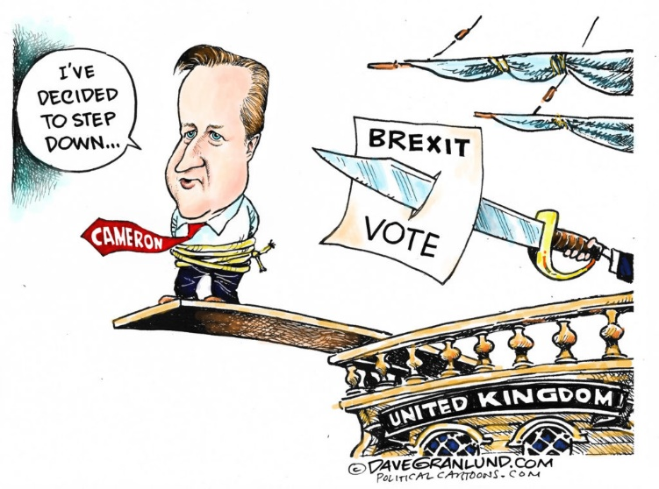

**Brexit:** After Brexit June 2016, we sew a fall in share price for sectors, such as construction and banks. These sectors will be more affected by an economic downturn. In a downturn, with falling house prices, we will see a big fall in demand for building new houses and demand for luxury items. Banks may lose out because of the decline in profitability and demand for loans. However, other sectors may prove more robust. For example, food and drink are less likely to be affected by a recession. Even in times of negative growth, people will still want to buy food and drink.

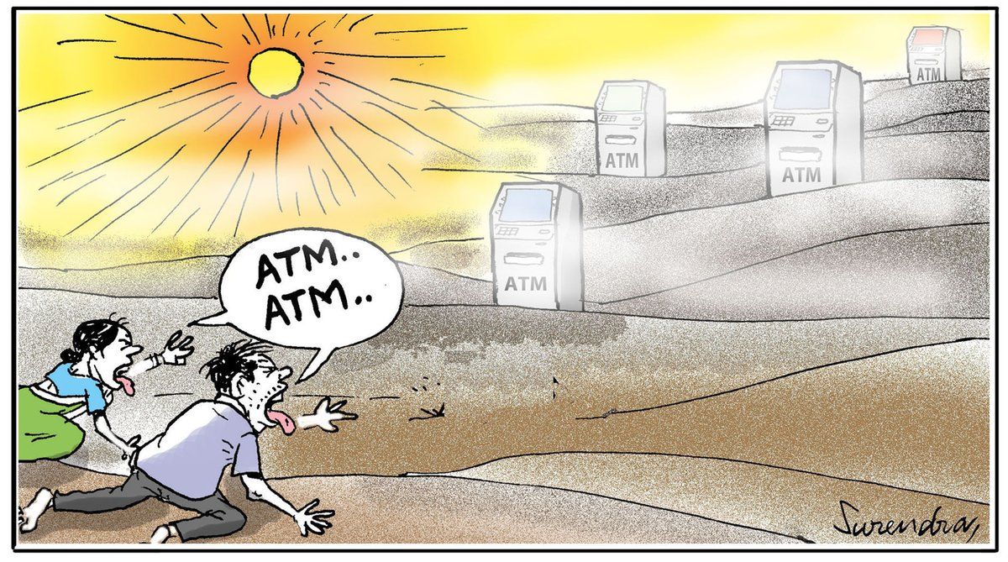

**Demonetisation:** Analysts and economists are now factoring in a major slowdown in growth for India Inc over the next few quarters.   
Market experts believe the cash crunch will create a temporary slowdown in the economy. This may result in a slower growth rate over the next two quarters. ***But demonetisation gave investors that brief window in which they can buy stocks on the cheap.***  The making indian market stable due to its previous phase

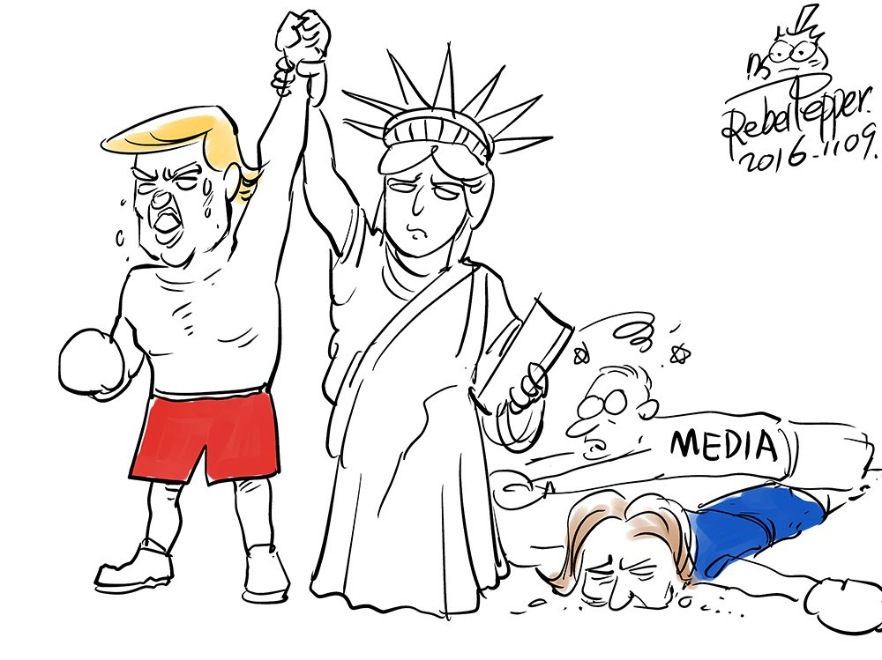

**Trump Win:** The victory took investors around the world by surprise and sent markets into a tailspin. Overnight, Dow futures fell as much as 800 points and the S&P 500 tumbled 5%, tripping up circuit breakers meant to halt trading in periods of extreme swings.

Markets also tumbled overseas as investors digested what a President Trump means for trade and global growth. Japan's Nikkei stock exchange finished 5.4% lower. European stocks also dropped initially, but by the end of the day the Stoxx Europe 600 had added 1.5%.

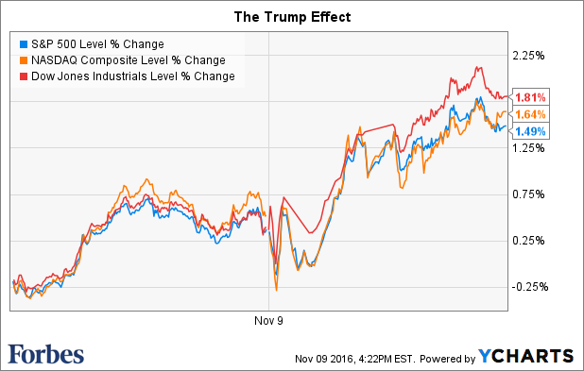

It's interesting to see that the market initially saw a Trump presidency as a negative but has come to the other side and the market was up later.

**Bibliography:**

# **Text Reference:**

# Gensler, Lauren. “Stock Market Slingshots Higher After Trump Victory Sparked Overnight Plunge”. Forbes NOV 9, 2016.Web.

* Kukowski, Mathew. “History of StockMarket”. Bebussinessed.Web.
* Mitchel, Cory. “How stock Exchange works”. Investopedia, 21 April 2016.Web
* Molloy, Mark. “Best Cartoons after trump victory”. Telegraph, 10 November, 2016.Web.
* Pettinger, Tejwan. “Relation Between stock market and economy”. EconomicsHelp, 18 July, 2016.Web.
* “Stock Market”.Wikipedia.Web.
* Viswanathan, Balaji.”How stock Market works? Who decides stock prices?”.Quora, May 10, 2013.Web.

**Image Reference:**

* “Engineer Syllogism”: http://xkcd.com/1570/.Image.
* “Market Watch”: https://xkcd.com/1600/.Image.

***"In the short term, the market is a voting machine. But, in the long term, the market is a weighing machine".  – Warren Buffett***